Control board Tutorial

# control board parts and schematics

### Parts list for the board:

|  |  |  |
| --- | --- | --- |
| Part | Amount | Notes |
| Custom control board | 1 | Can be found in the GitHub at: "GitHub\seeboat\hardware\controlBoard\controlBoard-0.5.brd" |
| 2.7 kΩ resistor, 0603 | 2 | Part number: RNCP0603FTD2K74CT-ND, <https://www.digikey.com/products/en?keywords=RNCP0603FTD2K74CT-ND> |
| DPDT switch | 1 | Part number: 401-2013-1-ND, <https://www.digikey.com/product-detail/en/AYZ0202AGRLC/401-2013-1-ND/1640122> |
| 4-pin header female | 4 | Part number: WM4802-ND, <https://www.digikey.com/products/en?keywords=WM4802-ND> |
| 3-pin header female | 1 | Part number: WM4801-ND, <https://www.digikey.com/products/en?keywords=WM4801-ND> |
| Male headers | 1 | Break to correct size:  <https://www.adafruit.com/product/392> |

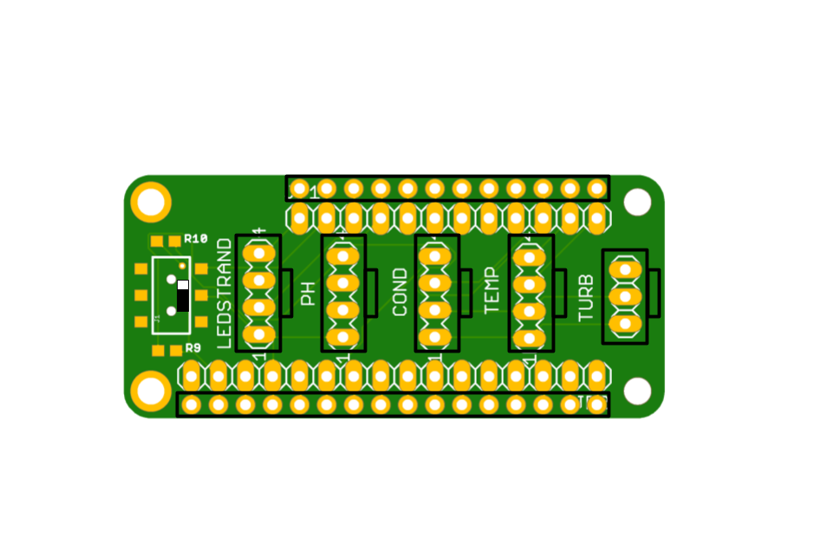

The schematic above details where each of the parts should go.

# Steps:

1. Solder on resistors, then the switch. Make sure the switch is oriented according to the schematic.
2. Solder on the 4-pin headers and the 3-pin, oriented in the right direction. It’s helpful to just solder one pin, then make sure the header is perpendicular to the board, and then solder the rest.
3. Solder on the male pin legs in the ***outer holes*** of the board. It’s helpful to use the female pin counterparts already soldered on a different board to help align the pins correctly. Insert the male pins into the other board, then set the control board on top and solder the pins.
4. All done!